**Chilean artists Tomás Díaz and Mauricio Nader will go on an European Tour Together**

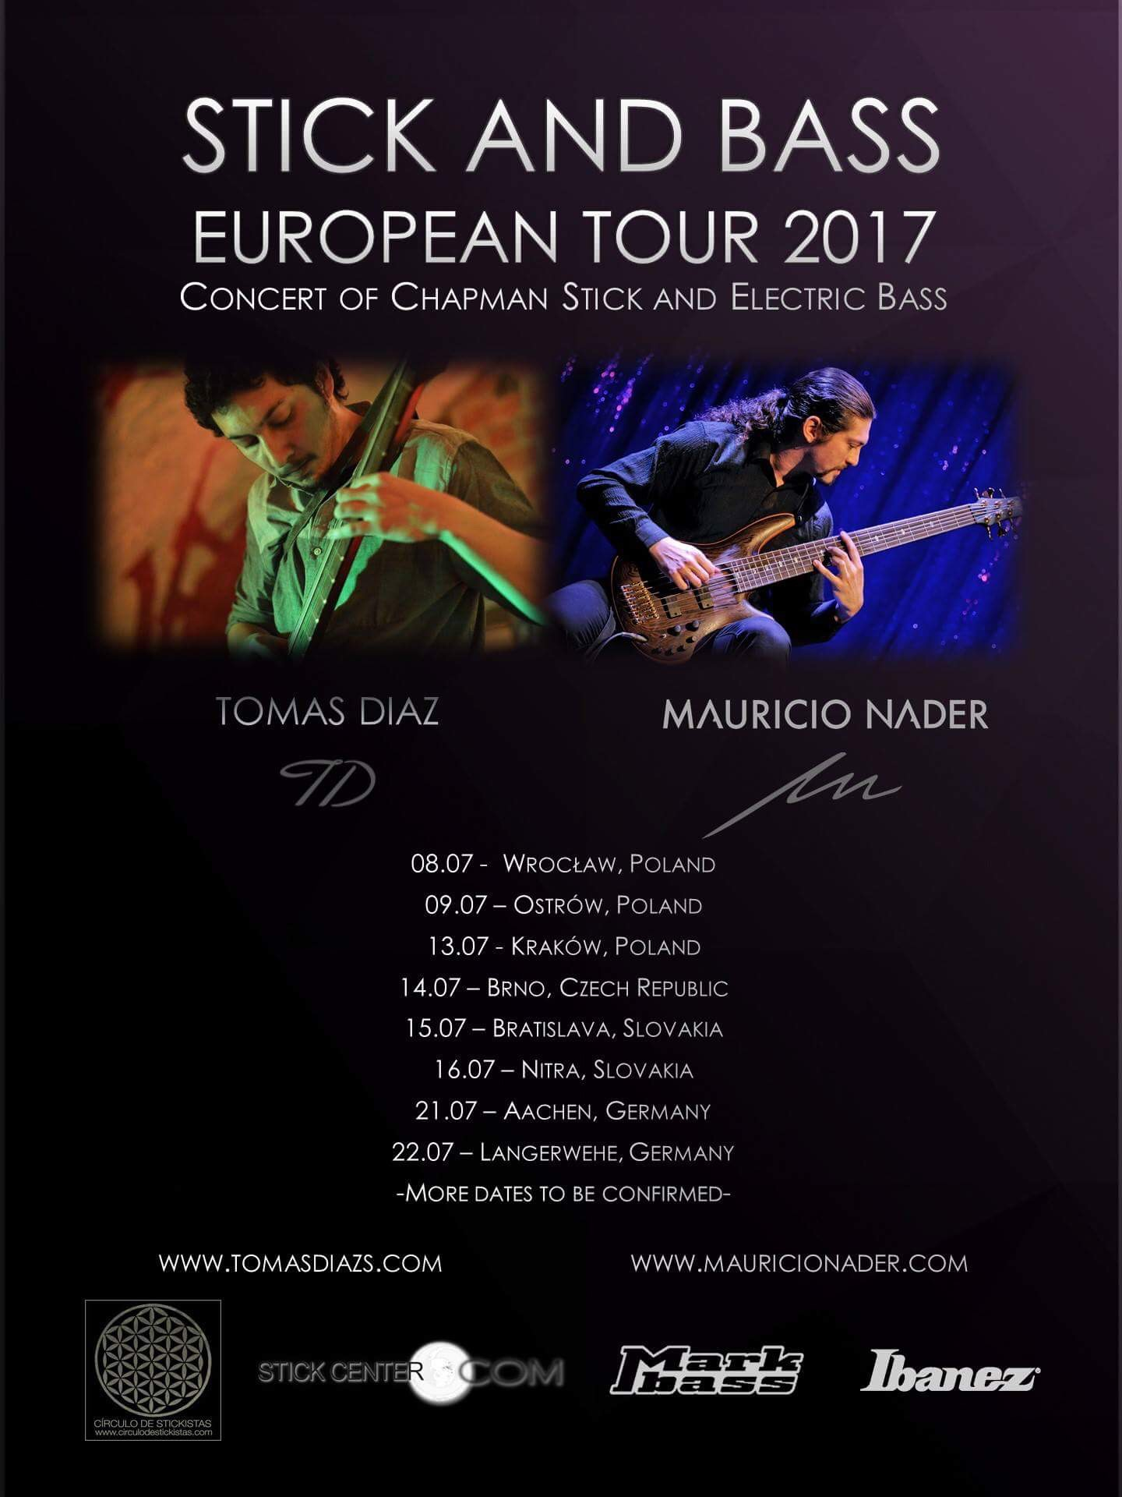

Every concert consists on pieces of universal character, played elegantly and emphasizing the classic style, Latin American folk music and own compositions. Each musician will play his solo material, Tomás Díaz on Chapman Stick and Mauricio Nader on Electric bass.  
With the purpose of enriching this show, Tomás and Mauricio come together to do an encore and perform music arranged for Chapman Stick and Electric Bass. The repertoire consists mostly in arrangements of Latin American folk songs, with a special sonority that gives the mixture of these two instruments. This last part of the show generates a very emotional closing to a show that will undoubtedly have to speak for its genius and innovation.

Tomás Díaz:

Audio engineer and self-taught musician born in Chile. His life is moving between art and technology, as much on the stage as behind it. He has worked in audio design for videos and advertising and also mixing albums for different artists, most of times for rock and metal projects but also for classical music, for example, the first album of the classical guitar duet Cruz&Souper from Rancagua, Chile.

Besides that, his work as musician has been varied, musical projects like the jazz trio Ciudad Antena where he was bass player for ten years, making arrangements for the "Festival Internacional de Viña del Mar" in 2008 and 2011, and making transcriptions for artist like the singer Pablo Silva, with whom also shared stage several times.

On the other hand, the discovering of a new musical instrument opened a new world of possibilities, nowadays, it has become a very important part of his career playing it as a soloist: the Chapman Stick, a stringed instrument devised in the 70's, fusion of electric guitar and electric bass usually played by "tapping", it means that fingers hit the strings against the fingerboard to make it vibrate, because of this, stick players can use both hands at the same time, playing melodies, chords and bass accompaniments simultaneously. His first EP "Opera Prima - Pieces for Chapman Stick" released in 2016 has received good comments even by the inventor of the Stick, Emmett Chapman, who refered to him as a promising musician.

Currently he is placed in Wrocław, Poland, is one of the founder members of the Chilean Stickist Collective, supported by the Free Hands Academy from United States and the Círculo de Stickistas, two independent group of musicians dedicated to promoting the Chapman Stick.

Mauricio Nader:

Mauricio was born in Santiago, Chile. He comes from the Rock and Metal world in which is part of several Chilean bands, and with them he has recorded ten studio albums, a live DVD and tour inside and outside Chile, including gigs and open-air festivals in Germany, Holland, Belgium, Switzerland, Slovakia and Turkey. He has also served as a teacher for over fifteen years and done master classes in Santiago and other regions of Chile.

For over five years, and parallel to his band projects, Mauricio Nader has work in the transcription, recording and live performance of classical and Latin-American folk musical pieces along with his own solo pieces compositions; all for solo six-strings electric bass. In 2015, release his first solo record titled "Solo Pieces for Electric Bass" and has touring Chile with over 100 concerts to promote this work. Last Augst 2016, he performed this work live at a concert in the city of Martin, Slovakia. Now, he is focusing in the promotion of his second solo album “The Four Seasons”, which consist in the entire transcription of this Vivaldi’s masterpiece, for solo electric bass.

Mauricio is not only well-known as an excellent musician, but also as a good motivator. It is demonstrated in his several conferences he constantly gives about entrepreneurship, innovation and improvement, both in music and in life. These conferences are given at cultural centres, theaters, colleges and town halls, and the essence of them are shown in the TEDx talk he gave in 2013, and includes him in the prestigious group that gave a TED talk for this foundation.

Among his principal achievements in his career, we can find a final award-nominee in the category “Performer of the Year” at Pulsar Prize 2016, which is the same as the Chilean Grammys. Also, he is world artist roster and endorsed by the Bass amplification brand MARKBASS, and the Guitars and Bass Instrument brand IBANEZ.

Tourdates:

July 8th - Wroclaw, Poland. Księgarnia Hiszpańska, Szajnochy 5, 20:00 hrs. - [www.ksiegarniahiszpanska.pl/](http://www.ksiegarniahiszpanska.pl/)

July 9th - Ostrów, Poland. Klub Stara Przepompownia, Raszkowska 78, 20:30 hrs. - [www.staraprzepompownia.pl/](http://www.staraprzepompownia.pl/)

July 13th - Kraków, Poland. Bonobo księgarnia kawiarnia podróżnicza, Mały Rynek 4, 20:00 hrs. - <http://bo-no-bo.pl/>

July 14th - Brno, Czech Republic. MusicLab, Opletalova 1, 602 00, 20:00 hrs. - [www.musiclab.cz/](http://www.musiclab.cz/)

July 15th - Bratislava, Slovakia. Kafe Scherz, Palisady 27, 20:30 hrs. - [www.scherz.sk](http://www.scherz.sk/)

July 16th - Nitra, Slovakia. Fotogaléria Trafačka, Janka Kráľa 65, 19:30 hrs. - [www.trafacka.sk/](http://www.trafacka.sk/)

July 21st - Aachen, Germany. Schluesseloch, Boxgraben 51, 20:00 hrs. - [www.schluesseloch-ac.de](http://www.schluesseloch-ac.de/)

July 22nd - Langerwehe, Germany. Töpfereimuseum, Pastoratsweg 1, 20:00 hrs. - [www.topfereimuseum.de](http://www.topfereimuseum.de/)

More info at:

[www.tomasdiazs.com](http://www.tomasdiazs.com)

www.mauricionader.com