Antonio Vivaldi - The Four Seasons

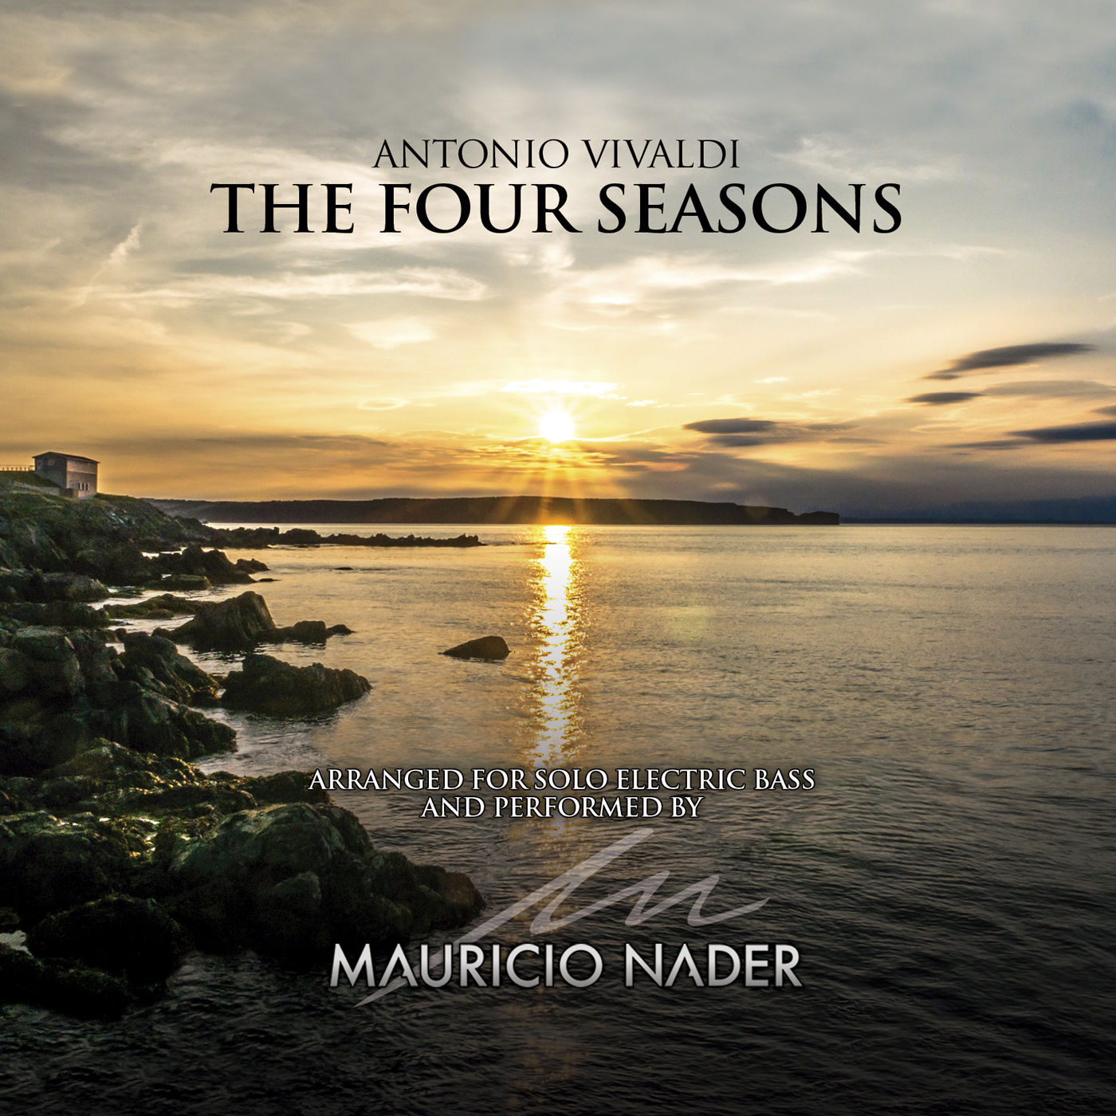

This is the second solo album recorded by Mauricio Nader. Published in 2017. It contains the entire transcription and arrangement for solo electric bass of Antonio Vivaldi's most famous masterpiece.

This record is a world-wide landmark in the history of the electric bass, since until now nobody had done a work of this magnitude for the instrument. The process of transcription, arranging, recording and mixing was made entirely by Mauricio, in different periods of time between May 2016 and April 2017. He himself has stated several times that "it was a huge challenge to achieve this work, since I had no reference to it, and my main purpose was to keep intact the essence of the work, in an instrument that was invented centuries after it was composed. " It should be noted that previously Mauricio had already transcribed one of the twelve movements that make up the work (Summer, 3rd movement), and that has always been included as a regular repertoire in their live shows.

Immediately after it was published, the album was promoted in an extensive tour through Chile during the months of May and June of 2017 covering 20 cities, and later on an important European tour in July of the same year.

Tracklist:

Spring

1. I Allegro
2. II Largo e pianissimo sempre
3. lll Allegro. Danza Pastorale

Summer
4. l Allegro non molto
5. II Adagio - Presto
6. III Presto. Tempo impetuoso d'Estate

Autumn

7. I Allegro - Larghetto - Allegro assai
8. II Adagio
9. III Allegro. La caccia

Winter

10. I Allegro non molto
11. II Largo
12. III Allegro

Credits:

Produced, recorded and mixed by Mauricio Nader, at different points between April, 2016 and January, 2017 at Arrow Studios, Santiago, Chile
Track 6 taken from the album “Solo Pieces for Electric Bass”, recorded in 2014 and published in 2015 by Mauricio Nader
All arrangements and transcriptions for electric bass made by Mauricio Nader
Recorded with an Ibanez SR 5006e six-strings electric bass and with a Markbass Little Mark III head
Mastered by Cristóbal Von Beck in January, 2017 at Vonbeck Studios, Santiago, Chile

Front cover, digipack and booklet design: Roberto Fernández (roberto.fernandez.vilos@gmail.com)
Booklet live picture: Cristian Soto
Digipack live picture: Rafael Bendek
Isotype and logo design: Rodrigo Contreras
Visual concept: Mauricio Nader

Electric bass calibration: Felipe Moroni (calibracionesmoroni@gmail.com)

For shows, tours, master classes, merchandising and all kinds of information, please write to:

info@mauricionader.com

www.mauricionader.com

(p) 2017

Mauricio Nader is worlwide endorsed by Ibanez Guitar and Basses, and Markbass Amps

Links:

Spotify: https://spoti.fi/2N0BYm5
Itunes: https://apple.co/2ItkFXm
Bandcamp: https://bit.ly/2KaAkki

